SNO | DESCRIPTION
 | ABSTRACT
CHAPTER -I | Introduction
CHAPTER-II | Literature Survey
CHAPTER-III | System analysis  3.1 Existing system  3.2 Proposed system
CHAPTER-IV | System Study
CHAPTER-V | Functional Requirements  5.1 Hardware Requirements  5.2 Software Requirements
CHAPTER-VI | System design  6.1 Architecture diagram  6.2 Component Diagram  6.3 ER Diagram  6.4 Use case Diagram  6.5 Class Diagram  6.6 Data flow diagram  6.7 Activity Diagram  6.8 Sequence Diagram
CHAPTER-VII | System development
CHAPTER-VIII | Implementation  8.1 Technologies used  8.2 About Python
CHAPTER-IX | Sample Code
CHAPTER-X | Screenshots
CHAPTER-XI | System testing
CHAPTER-XII | Conclusion
CHAPTER-XIII | Reference

PROBLEM STATEMENT
Self-harm pertains to actions of self-inflicted poisoning or injury that lead to either nonfatal injuries or death, irrespective of the individual’s intention. Self-harm incidents not only cause loss to individuals but also incur a negative impact on the nation’s economy
OBJECTIVE
Self-harm refers to intentional self-poisoning or self-injury, regardless of the nature of the motivation or the severity of suicidal intent, that could result in injury or death. Self-harm and suicide have been prevalent problems, especially in developing countries [9]. According to a recent study, a significant proportion of suicide cases, approximately 77%, were observed in low- and middle-income countries
ABSTRACT
Self-harm pertains to actions of self-inflicted poisoning or injury that lead to either nonfatal injuries or death, irrespective of the individual’s intention. Self-harm incidents not only cause loss to individuals but also incur a negative impact on the nation’s economy. Studies have demonstrated an increase in trends of self-harm that are correlated with the emergence of technological advancements and swift urban expansion in developing countries. The capacity to nowcast and forecast national-level patterns of self-harm trends could be imperative to policymakers and stakeholders in the public health sector, as it would enable them to implement prompt measures to counteract the underlying factors or avert these projected calamities. Prior research has utilized historical data to predict self-harm trends at the population level in various nations using conventional statistical forecasting methods. However, in some countries, such historical statistics may be challenging to obtain or insufficient for accurate prediction, impeding the ability to comprehend and project the national self-harm landscape in a timely manner. This paper proposes FAST, a framework designed to forecast self-harm patterns at the national level by analyzing mental signals obtained from a large volume of social media data. These signals serve as a proxy for real-world population mental health that could be used to enhance the forecastability of self-harm trends. Specifically, language-agnostic language models are first trained to extract different mental signals from collected social media messages. Then, these signals are aggregated and processed into multi-variate time series, on which the time-delay embedding algorithm is applied to transform into temporal embedded instances. Finally, various machine learning regressors are validated for their forecastability. The proposed method is validated through a case study in Thailand, which
utilizes a set of 12 mental signals extracted from tweets to forecast death and injury cases resulting from selfharm. The results show that the proposed method outperformed the traditional ARIMA baseline by 43.56% and 36.48% on average in terms of MAPE on forecasting death and injury cases from self-harm, respectively. As far as current understanding permits, our research represents the initial exploration of utilizing aggregated social media information for the purposes of nowcasting and forecasting trends of self-harm on a nationwide scale. The results not only provide insight into improved forecasting techniques for self-harm trends but also establish a foundation for forthcoming social-network-driven applications that hinge on the capacity to predict socioeconomic factors.

CHAPTER-1
INTRODUCTION
Self-harm, a critical public health issue, has garnered increasing attention due to its rising prevalence and severe impact on individuals and communities. Accurate forecasting of self-harm trends is essential for developing effective interventions, allocating resources, and implementing preventive measures. Traditional methods of tracking and forecasting self-harm trends often rely on clinical data and survey reports, which, while valuable, may not provide real-time or comprehensive insights into emerging patterns. In recent years, social networks have emerged as a powerful tool for understanding and forecasting behavioral trends. Platforms such as Twitter, Facebook, and Reddit generate vast amounts of user-generated content that reflects a wide range of emotions, behaviors, and social interactions. Analyzing this data can provide valuable insights into public sentiment, mental health issues, and self-harm behaviors, offering a complementary approach to traditional data sources. Social networks offer several advantages for forecasting self-harm trends. The real-time nature of social media posts allows for the monitoring of emerging issues and patterns as they develop. By leveraging natural language processing (NLP) and machine learning techniques, researchers can analyze large volumes of social media data to identify signals related to self-harm. This approach enables the detection of trends and patterns that might not be evident from traditional data sources, such as increases in self-harm discussions or changes in sentiment. Moreover, social networks can provide a broader and more diverse perspective on self-harm behaviors across different demographics and regions. By analyzing posts from a variety of social network platforms, researchers can gain insights into how self-harm trends vary across different populations and locations. This can help in understanding regional differences, identifying at-risk groups, and tailoring interventions to meet specific needs. However, the use of social network data for forecasting self-harm trends also presents several challenges. Issues such as data privacy, the accuracy of self-reported behaviors, and the representativeness of social media samples must be addressed to ensure reliable and ethical research. Additionally, the complexity of social media language and the potential for misinformation or misleading posts require careful analysis and interpretation. The exacerbation of incidents involving self-harm not only results in personal grief and loss but also has enduring adverse effects on the economy, primarily due to the reduction in long-term labor productivity [41]. The ability to monitor and forecast population-level self-harm trends could prove vital to national-level policymakers and public healthcare stakeholders in devising means to timely gauge the situations and implement procedures to neutralize or prevent such anticipated tragedies [70]. For example, upon being informed that certain stringent policies aimed at addressing nationwide epidemics have led to mental health issues among citizens and are expected to contribute to a significant increase in self-harm trends, policymakers may consider making appropriate modifications to the current policies that are causing these issues. Furthermore, the implementation of public health interventions, such as mobile psychiatry units or hotlines, could be deployed to target populations experiencing adverse effects. Presently, the techniques employed to acquire knowledge about selfharm trends at the national level depend on administrative reports from healthcare centers and hospitals across the country. This approach necessitates significant financial, human, and time resources, leading to infrequent and delayed data availability. Statistics that are coarse-grained and delayed may have limited utility for the purpose of proactive policy-making. The need for monitoring and forecasting trends in self-harm and suicide has been highlighted in recent literature [63]. The problem has been framed as a time series forecasting task, with conventional techniques such as ARIMA and the Holt-Winters methods being applied [71], [90]. Recent research has illuminated the diverse individual and external factors that influence the decision-making process of individuals to engage in acts of self-harm [22], [66]. According to Chang and Lee [17], relying solely on historical self-harm and suicide statistics may not be adequate for developing precise forecasting models. This highlights the need for supplementary data sources that capture the population’s reactions to current self-harm and suicide trends. In this direction, previous literature has examined the potential of utilizing Google Trends data, specifically search queries related to self-harm and suicide, to enhance the accuracy of national-level self-harm forecasting [39]. However, recent research has indicated that Google Trends may not be an appropriate proxy for measuring aggregate self-harm behavior. This is mainly due to the undisclosed algorithm that governs the mechanism of Google Trends [25], as well as the assumption that there is a great overlap between the population that generates Google search queries and those who actually engage in self-harm acts [91]. In addition, a recent academic investigation has revealed that the employment of self-harm-related keywords in Google Trends statistics did not correlate strongly with actual self-harm statistics in Thailand [62]. To fill the gap in the lack of a good timely indicator, we propose utilizing extensive online social media data as a feasible proxy for collective self-harm behavior. The potential connections between social media platforms, including Twitter and Facebook, and suicidal ideation have been explored in previous research studies [53], [82], [84]. Conversely, other studies have employed social media to monitor and forecast incidents of self-harm and suicide among individuals [55], [78]. Nevertheless, the utilization of social media as a means of predicting self-harm and suicide tendencies at an aggregate level has yet to be explored.
1.2. LITERATURE REVIEW
- Wang et al. [95], individuals with mental disorders tend to feel more at ease expressing their thoughts on social media platforms. Not only that, the usage of social media has been linked to worsened mental health, especially among young adults, [12], as well as higher rates of suicide and self-harm [1]. Therefore, it is reasonable to infer that indicators extracted from social media could be a good proxy for the rising rates of populationlevel self-harm, since a significant portion of social media users may either openly discuss negative mental conditions on these platforms or their negative mental health states can be implicitly inferred from their expressions on social media. Under this conjecture, the characteristics that signify the cognitive states of the message’s author may function as a proxy for their current or future mental health states and behaviors. According to a recent study [62], there exists a strong correlation between collective mental signals, including fear, sadness, disgust, and suicidal tendencies, extracted from social media messages and the national incidence of injuries and deaths resulting from self-harm in Thailand. Building upon prior research, our proposed framework involves utilizing extensive social media data as a proxy for measuring the population’s mental health, which can be leveraged to forecast nationwide self-harm patterns.
- The ability forecast the aggregate-level self-harm trends could prove useful not only to policymakers in analyzing the root causes for policy interventions but also to public healthcare stakeholders for dispatching remedies to mitigate and combat the issues [45]. Indeed, the ability to forecast self-harm and suicide rates has been investigated since 1978, where simple statistical techniques, such as the Box-Jenkins method, were used for forecasting suicidal rates using historical statistics [94]. The advent of Internet technologies has facilitated convenient access to online information, most of which through a web search. Later studies have investigated utilizing these web search queries as proxies to monitor suicide trends at the national level [10], [91]. However, in certain developing countries, for example, Thailand, these web search queries were not found to correlate to self-harm and suicide trends, possibly due to the underlying population which produced these search queries, which could be different from those actually committing self-harm [62]. Recently, with the rise of online social networking services as alternative and complement platforms for communication, several studies have investigated both their contribution to causes of self-harm and suicide [53], [59] and purposes as a proxy to assess self-harm and suicide risks in potential mental disorder patients [28], [69]. Online social networking data has been established as potential sources for monitoring real-world phenomena both at the individual and aggregate levels. For example, Twitter and Facebook data have been used to predict individual flu infection [73] and forecast the trends at the national level [67]. Many studies have extended the use of social media data for tracing and forecasting selfharm and suicide risks in individuals [11], [40]; however, the use of such large-scale user-generated data for forecasting population-level self-harm and suicide trends has yet to surface. Therefore, to provide a comprehensive background and related work, this section first discusses previously proposed methods for individual-level self-harm prediction. Then, the next subsection reviews related work on forecasting selfharm and suicide trends at the national level, both using traditional historical statistics and online information (e.g., Google Trends)
- IN “ABSOLUTIST WORDS FROM SEARCH VOLUME DATA PREDICT STATE-LEVEL SUICIDE RATES IN THE UNITED STATES” Suicide continues to be a major public health issue, especially in the US. It is a well- established fact that depression and suicidal ideation are risk factors for suicide. Drawing upon recent research which shows that absolutist words (e.g. ‘completely’, ‘totally’) constitute linguistic markers of suicidal ideation, we created an online index of absolutist thinking (ATI) using search query data (i.e. Google Trends time series). Mixed-model analyses of age-adjusted suicide rates in the US from 2004-2017, revealed that ATI is linked with suicides β = .22, 95%CI[.12, .31], p < .001 and predicts suicides within one year β = .16, 95%CI[.05, .28], p = .006 independently of state characteristics and historical trends. It is the first time that a collective measure of absolutist thinking is used to predict real-world suicide outcomes. Therefore, the present study paves the way for novel research avenues in clinical psychological research. Suicide remains a significant public health issue, with an estimated 40,000 yearly casualties in the United States alone, leading to an approximate cost of over $44 billion each year for the US economy due to medical and work loss costs (CDC, 2017). Therefore, finding ways to monitor, anticipate and predict suicide deaths is of central interest to engage in preventive actions aimed at the general population.
- One current approach to do so consists in leveraging information from social media data to compute online indexes that are linked with suicide rates (Won, Myung, Song, Lee, Kim, Carroll, & Kim, 2013). Though this approach yields interesting results, it remains complicated to use for applied purposes given privacy concerns regarding social media. Moreover, there is heterogeneity in what constitutes appropriate indexes, which are often more empirically (data) driven than based on reliable psychological theorizing. For instance, Won et al.’s (2013) suicide indicator (computed from suicide-related content on social media posts) was very susceptible to celebrity suicide events and displayed high variability, indicating the broad and noisy character of this measure.
- This is why we decided to test whether a simple, yet robust online index could be computed from readily accessible online data, which would predict real-life suicide deaths. To achieve this, we turned to clinical psychological theory to identify potent constructs that can be tapped into by linguistic markers. Among several identified risk factors for suicide deaths some of the most potent remain depression and suicide ideation (Ribeiro, Huang, Fox, & Franklin, 2018). Incidentally, a promising candidate for operationalizing linguistic traces of both is absolutist thinking (Beck, 1979). In a nutshell, absolutist thoughts are context-independent and devoid of nuance. Absolutist and non-absolutist concepts both refer to magnitudes or probabilities, but absolutist thoughts differ from non-absolutist ones in that they preclude any kind of gradation (‘completely’ vs. ‘somewhat’ for instance). Currently, it is established that increased absolutist thinking is associated with anxiety, depression and suicidal ideation (Al-Mosaiwi & Johnstone, 2018). In line with this, absolutist words have been found more prevalent among suicidal patients (Neuringer, 1964) and in writings of suicidal individuals (Wedding, 2000). Though the exact cognitive mechanisms at play remain the target of ongoing investigations, cognitive rigidity and impairment of problem-solving abilities are co-morbid with depression and suicidal ideation (Ellis & Rutherford, 2008; Williams & Pollock, 2008). Consequently, recent research has validated a dictionary of 19 words which are linguistic markers of absolutist thinking (e.g. ‘completely’, ‘totally’) and therefore more prevalent among online posts from forums about depression and suicide (Al-Mosaiwi & Johnstone, 2018). Thus, it is theoretically expected that an aggregated index using these words’ prevalence from online data sources could be a useful proxy for collective-level depression and suicidal ideation. The present research To compute thus indicator, we decided to use search volume data from Google Trends. In short, Google Trends provides researchers with the frequency at which a specific search term is typed, compared to all different search terms across specified languages and geographical areas (Google, 2017). These data are publicly available and can be easily retrieved, making them a perfect fit for our purpose. Furthermore, search entries are predictive of real-life phenomena, such as stock markets fluctuations (from words like ‘crisis’ or ‘subprime’ see Preis, Reith, & Stanley, 2010) and consumer behaviour (Jun, Yoo, & Choi, 2018). Also, when extracting data regarding a specific word in Google Trends it is possible to retrieve its prevalence among all search entries in a given population. For example, data extracted for the word ‘completely’ would count each time this word was contained in every request among the population and area of interest during a specified time span (for more information regarding the inner workings and applications of Google Trends data see also Yun et al., 2018; Troian, Arciszewski, & Apostolidis, 2019). Thus, we decided to investigate whether aggregated search volume data computed from the absolutist word dictionary could predict suicide deaths at the state level across US. In line with Al-Mosaiwi & Johnstone (2018), we hypothesized that an aggregated linguistic measure of state-level absolutist thinking should be positively linked with suicide rates, and that this measure should also be predictive of state-level suicide rates in time.
- IN “SOCIAL MEDIA-AND INTERNET-BASED DISEASE SURVEILLANCE FOR PUBLIC HEALTH,” Disease surveillance systems are a cornerstone of public health tracking and prevention. This review addresses the use, promise, perils, and ethics of social media- and Internet-based data collection for public health surveillance. Our review highlights untapped opportunities for integrating digital surveillance in public health and current applications that could be improved through better integration, validation, and clarity on rules surrounding ethical considerations. Promising developments include hybrid systems that couple traditional surveillance data with data from search queries, social media posts, and crowdsourcing. In the future, it will be important to identify opportunities for public and private partnerships, train public health experts in data science, reduce biases related to digital data (gathered from Internet use, wearable devices, etc.), and address privacy. We are on the precipice of an unprecedented opportunity to track, predict, and prevent global disease burdens in the population using digital data. Disease surveillance in the community setting is a cornerstone of public health tracking and prevention. The World Health Organization defines public health surveillance as “the continuous, systematic collection, analysis, and interpretation of health-related data needed for the planning, implementation, and evaluation of public health practice” (108; see a related definition from Reference 76). Public health surveillance acts as a sentinel for identifying trends in disease and emerging public health concerns and can help to identify potential points of intervention. Furthermore, surveillance data can provide benchmarks for evaluating intervention measures for curbing disease spread in populations and allow health experts to set priorities and policies. Surveillance has undergone numerous changes over the years (20) and will likely continue to evolve. Recent changes in disease surveillance systems are a result of technological advances for data collection related to access to the Internet and improved computational power. Digital disease surveillance can be defined as the use of Internet-based data in the explicit development or application of systems aimed at nowcasting or forecasting of disease incidence or prevalence (72). In recent years, Internet-based search tools and social media have created exciting new prospects for expanding disease surveillance by capturing real-time data and trends for health outcomes.

CHAPTER-2
SYSTEM ANALYSIS
EXISTING SYSTEM :
EXISTING SYSTEM
Traditional approaches to forecasting self-harm trends primarily rely on historical health records, hospital reports, and administrative data collected over time. These conventional methods have been widely used in public health research and policymaking but face several critical limitations.
1. Statistical Models for Self-Harm Forecasting
The most commonly used forecasting models include:
1.1 ARIMA (Autoregressive Integrated Moving Average)
- ARIMA is a widely adopted time-series forecasting technique that models data based on past observations.
- Studies such as Preti and Lentini (2016) and Swain et al. (2021) have used ARIMA to predict suicide and self-harm trends in different countries.
- However, ARIMA assumes linear relationships and struggles with non-stationary and complex behavioral trends in self-harm data.
1.2 Holt-Winters and Exponential Smoothing Methods
- These models focus on capturing seasonal variations in self-harm incidents.
- While they help identify cyclical trends, they do not account for external factors such as economic conditions, social media influences, or psychological triggers.
2. Dependence on Delayed and Limited Data
- Traditional self-harm forecasting heavily relies on hospital and public health reports, which are often delayed by months or years.
- Underreporting and stigma surrounding self-harm and mental health issues further limit data availability, leading to incomplete datasets.
- These limitations make it difficult to respond proactively to emerging mental health crises.
3. Google Trends and Web-Based Forecasting Attempts
- Some researchers have turned to Google search queries to predict self-harm trends, assuming that spikes in searches for terms like "suicide prevention" correlate with real-world self-harm cases.
- However, this approach has severe reliability issues:
  - Google Trends' algorithm is non-transparent, making reproducibility difficult.
  - There is no guarantee that individuals searching for self-harm-related topics are at risk themselves.
  - Cultural and linguistic differences affect search behavior, reducing the model's generalizability.
4. Crisis Hotline and Mental Health Service Data
- Some studies have analyzed suicide prevention hotline call volumes as a proxy for self-harm trends.
- While valuable, hotline data represents only a fraction of individuals in distress, as many at-risk individuals do not seek help.
5. Limitations of the Existing System
Based on the above observations, the current forecasting systems face several key limitations:
- Data Latency – Reliance on hospital and public health records results in outdated predictions.
- Underreporting – Many self-harm incidents go unrecorded due to stigma and lack of healthcare access.
- Lack of Real-Time Indicators – No incorporation of social or psychological triggers in forecasting models.
- Limited Accuracy – Traditional models fail to account for non-linear, behavioral, and societal factors that influence self-harm trends.
- Generalization Issues – Search query trends and crisis hotline data do not universally reflect self-harm risks across demographics.
Given these shortcomings, there is a need for an enhanced forecasting framework that leverages real-time social media data and advanced machine learning techniques to improve the accuracy and timeliness of self-harm trend predictions

PROPOSED SYSTEM:
To overcome the limitations of traditional self-harm forecasting approaches, we propose a novel machine learning-based framework that integrates real-time mental health indicators from social media with historical self-harm statistics. The proposed system enhances forecasting accuracy by leveraging large-scale social media data to extract psychological signals, such as emotions, sentiments, and suicidal tendencies, which serve as leading indicators of self-harm trends.
1. Key Features of the Proposed System
1.1 Social Media as a Real-Time Data Source
- The system collects large-scale social media posts (e.g., tweets) to analyze emotional distress signals at a population level.
- Instead of relying solely on delayed health records, our framework uses real-time psychological indicators from individuals discussing mental health issues online.
1.2 Machine Learning-Based Forecasting Model
- We implement XGBoost, an advanced machine learning algorithm, to predict self-harm incidents based on multivariate time-series data.
- Unlike ARIMA, XGBoost captures non-linear relationships and temporal dependencies, significantly improving predictive accuracy.
1.3 Mental Signal Extraction and Time-Series Aggregation
- Our framework quantifies mental signals from social media posts using a language-agnostic model trained to detect emotions, sentiments, and suicidal ideation.
- These signals are aggregated and processed into multivariate time series, which are used as features in forecasting models.
1.4 Time-Delay Embedding for Enhanced Forecasting
- We apply time-delay embedding to capture historical dependencies in both social media mental signals and past self-harm incidents.
- This allows the model to learn from long-term behavioral patterns, enhancing its ability to make future predictions.
1.5 Comparative Analysis Against Traditional Models
- The proposed system is empirically validated against ARIMA and other statistical baselines to demonstrate its superiority.
- Our case study in Thailand shows that integrating social media signals with machine learning improves forecasting accuracy by 43.56% for self-harm-related deaths and 36.48% for injury cases compared to ARIMA.

2. System Workflow
The proposed framework follows a structured pipeline to collect, process, and predict self-harm trends:
Step 1: Data Collection
- Social Media Data: Large-scale Twitter data is collected through official APIs.
- Historical Self-Harm Data: Ground-truth statistics are gathered from national health organizations.
Step 2: Mental Signal Extraction
- A deep learning classifier identifies emotions (e.g., sadness, fear), sentiments (positive, negative), and suicidal tendencies in social media posts.
Step 3: Data Aggregation and Normalization
- Extracted mental signals are aggregated into monthly time-series datasets and normalized to ensure consistency across different periods.
Step 4: Feature Engineering and Time-Delay Embedding
- Temporal dependencies are modeled using lagged features, allowing the system to capture historical behavioral patterns.
Step 5: Machine Learning Model Training
- The XGBoost regressor is trained on both historical self-harm statistics and aggregated mental signals to forecast future trends.
Step 6: Forecasting and Evaluation
- Model performance is evaluated using Mean Absolute Percentage Error (MAPE), demonstrating a significant improvement over ARIMA.
3. Advantages of the Proposed System
✅ Real-Time Monitoring – Unlike traditional models, our framework incorporates up-to-date psychological indicators from social media.
✅ Improved Forecasting Accuracy – Machine learning captures complex, non-linear relationships in self-harm data, outperforming statistical models.
✅ Early Warning System – Predicts self-harm trends before they manifest in hospital records, enabling proactive interventions.
✅ Scalability and Adaptability – The system can be generalized across different countries and languages, supporting global self-harm forecasting.
✅ Comprehensive Data Utilization – Combines historical statistics with social media-derived mental signals, providing a holistic view of self-harm trends.
Conclusion
The proposed system represents a major advancement in self-harm forecasting by integrating real-time social media signals with machine learning techniques. By leveraging XGBoost and deep-learning-based mental signal extraction, our framework significantly outperforms traditional statistical models, providing more accurate, timely, and actionable insights for policymakers and mental health professionals.
Future enhancements will explore the use of deep learning models, multimodal data sources, and demographic-specific forecasting to further improve predictive performance and real-world applicability.

System Architecture:

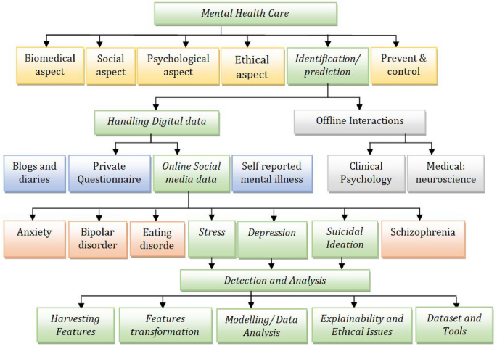

CHAPTER 3
METHODOLOGY
3.1 MACHINE LEARNING ALGORITHMS
Machine learning algorithms are computational models that enable machines, particularly computers, to learn from data and make predictions or decisions without being explicitly programmed. These algorithms utilize statistical techniques to recognize patterns, learn from experience, and improve their performance over time as they are exposed to more data.
3.2. RANDOM FOREST
Random forests or random decision forests are an ensemble learning method for classification, regression and other tasks that operates by constructing a multitude of decision trees at training time. For classification tasks, the output of the random forest is the class selected by most trees. For regression tasks, the mean or average prediction of the individual trees is returned. Random decision forests correct for decision trees' habit of overfitting to their training set. Random forests generally outperform decision trees, but their accuracy is lower than gradient boosted trees. However, data characteristics can affect their performance.
The first algorithm for random decision forests was created in 1995 by Tin Kam Ho[1] using the random subspace method, which, in Ho's formulation, is a way to implement the "stochastic discrimination" approach to classification proposed by Eugene Kleinberg.
An extension of the algorithm was developed by Leo Breiman and Adele Cutler, who registered "Random Forests" as a trademark in 2006 (as of 2019, owned by Minitab, Inc.).The extension combines Breiman's "bagging" idea and random selection of features, introduced first by Ho[1] and later independently by Amit and Geman[13] in order to construct a collection of decision trees with controlled variance.
Random forests are frequently used as "blackbox" models in businesses, as they generate reasonable predictions across a wide range of data while requiring little configuration.
GRADIENT BOOSTING
Gradient boosting is a machine learning technique used in regression and classification tasks, among others. It gives a prediction model in the form of an ensemble of weak prediction models, which are typically decision trees.^{[1][2]} When a decision tree is the weak learner, the resulting algorithm is called gradient-boosted trees; it usually outperforms random forest.A gradient-boosted trees model is built in a stage-wise fashion as in other boosting methods, but it generalizes the other methods by allowing optimization of an arbitrary differentiable loss function.

3.3 MATPLOTLIB
Matplotlib is a Python 2D plotting library which produces publication quality figures in a variety of hardcopy formats and interactive environments across platforms. Matplotlib can be used in Python scripts, the Python and IPython shells, the Jupyter notebook, web application servers, and four graphical user interface toolkits. It provides a variety of functions to visualize data and create static, animated, and interactive plots. Matplotlib is widely used for tasks ranging from simple line plots to complex visualizations.

The Visualization Design using matplotlib
- Bar Graph
- Pie Chart
- Box Plot
- Histogram
- Line Chart and Subplots
- Scatter Plot

3.4 BAR GRAPH
Bar graphs are best used when we need to compare the quantity of categorical values within the same category. Bar graphs should not be used for continuous values.
Bar graph is generated using plt.bar() in matplotlib
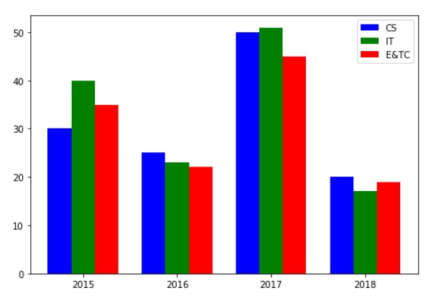
Figure 3.3. Bar Graph

3.5 PIE CHART USING MATPLOTLIB
A pie chart is suitable to show the proportional distribution of items within the same category.plt.pie() is used to draw the pie chart and adjust its parameters to make it more appealing.
A pie chart is rendered useless when there are a lot of items within a category. This will decrease the size of each slice and there will be no distinction between the items.
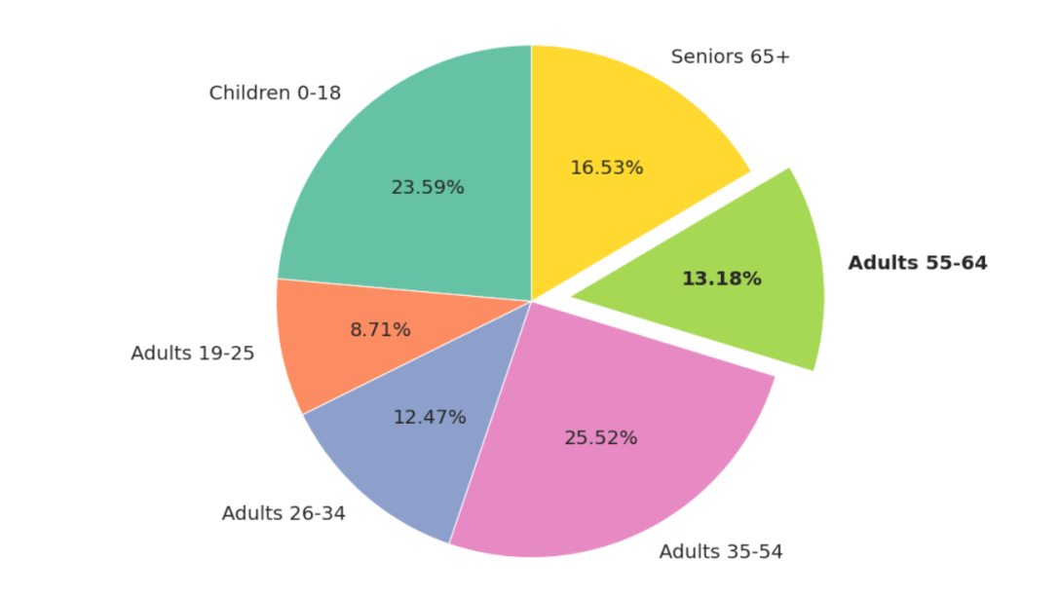
Figure 3.4. Pie Chart

3.6 BOX PLOT USING MATPLOTLIB
Box plot gives statistical information about the distribution of numeric data divided into different groups. It is useful for detecting outliers within each group. The lower, middle and upper part of the box represents the 25th, 50th, and 75th percentile values respectively. Box plot does not show the distribution of data points within each group.
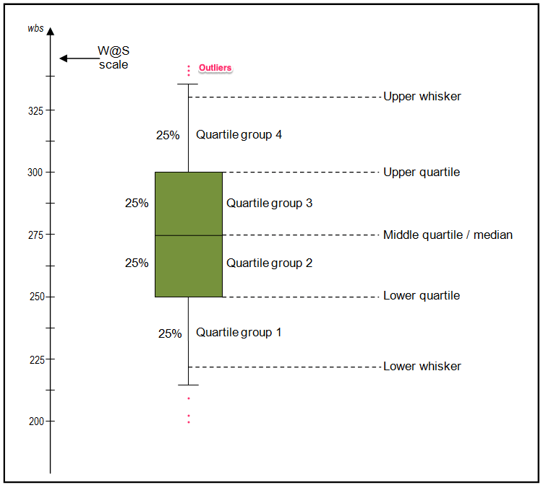
Figure 3.5. Box Plot

3.7 HISTOGRAM USING MATPLOTLIB
A histogram shows the distribution of numeric data through a continuous interval by segmenting data into different bins. Useful for inspecting skewness in the data. It is easy to confuse histograms with bar plots. But remember, histograms are used with continuous data whereas bar plots are used with categorical data.
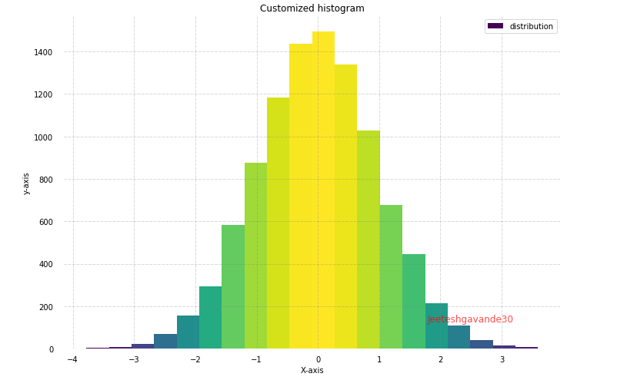
Figure 3.6. Histogram

3.8 LINE PLOT AND SUBPLOTS USING MATPLOTLIB
A line plot is useful for visualizing the trend in a numerical value over a continuous time interval. Matplotlib subplots makes it easy to view and compare different plots in the same figure. The plt.subplots() figure returns the figure and axes. You can provide as an input to the function how you want to display the axes within the figure. These will be adjusted using the nrows and ncols parameters. You can even adjust the size of the figure using the figsize parameter.
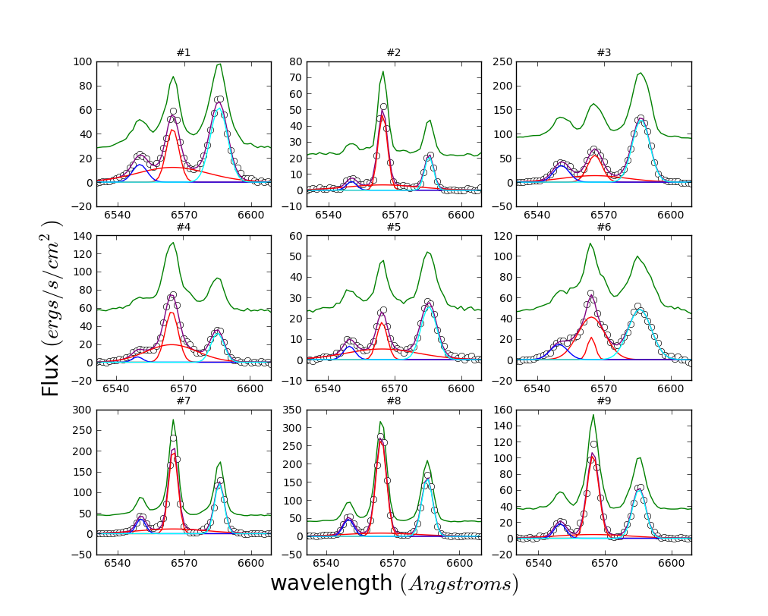
Figure 3.7. Subplot

3.9 SCATTER PLOT USING MATPLOTLIB
Scatter plots are useful for showing the relationship between two variables. Any correlation between variables or outliers in the data can be easily spotted using scatter plots.
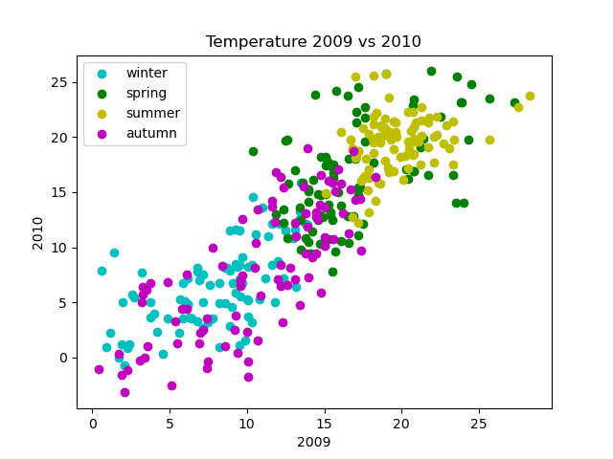
Figure 3.8. Scatter Plot
3.10 SEABORN
Seaborn is a statistical data visualization library based on Matplotlib. Seaborn is a powerful and flexible data visualization library in Python that offers an easy-to-use interface for creating informative and aesthetically pleasing statistical graphics. It provides a range of tools for visualizing data, including advanced statistical analysis, and makes it easy to create complex multi-plot visualizations..Seaborn's key benefit lies in its capability to generate attractive plots with minimal coding efforts. It provides a range of default themes and color palettes, which you can easily customize to suit your preferences. Additionally, Seaborn offers a range of built-in statistical functions, allowing users to easily perform complex statistical analysis with their visualizations. Another notable feature of Seaborn is its ability to create complex multi-plot visualizations. With Seaborn, users can create grids of plots that allow for easy comparison between multiple variables or subsets of data. This makes it an ideal tool for exploratory data analysis and presentation.
3.11 PLOT TYPES IN SEABORN
- LINE PLOT: Line plots are used to visualize trends in data over time or other continuous variables. In a line plot, each data point is connected by a line, creating a smooth curve. In Seaborn, line plots can be created using the lineplot() function.
- HISTOGRAM: Histograms visualize the distribution of a continuous variable. In a histogram, the data is divided into bins and the height of each bin represents the frequency or count of data points within that bin. In Seaborn, histograms can be created using the histplot() function.
- BOX PLOT: Box plots are a type of visualization that shows the distribution of a dataset. They are commonly used to compare the distribution of one or more variables across different categories.
- VIOLIN PLOT: A violin plot is a type of data visualization that combines aspects of both box plots and density plots. It displays a density estimate of the data, usually smoothed by a kernel density estimator, along with the interquartile range (IQR) and median in a box plot-like form. The width of the violin represents the density estimate, with wider parts indicating higher density, and the IQR and median are shown as a white dot and line within the violin.
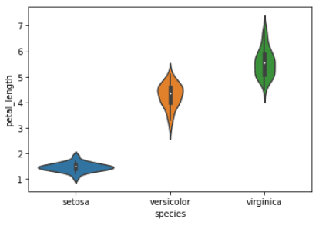
Figure 3.9. Violin Plot
- HEATMAP. A heatmap is a graphical representation of data that uses colors to depict the value of a variable in a two-dimensional space. Heatmaps are commonly used to visualize the correlation between different variables in a dataset.
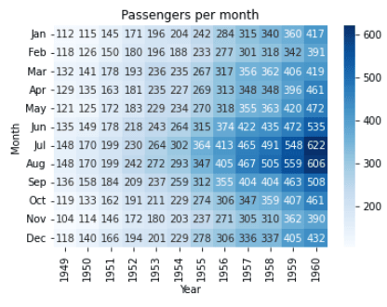
Figure 3.10. Heat Map
- PAIRPLOT: Pair plots are a type of visualization in which multiple pairwise scatter plots are displayed in a matrix format. Each scatter plot shows the relationship between two variables, while the diagonal plots show the distribution of the individual variables.
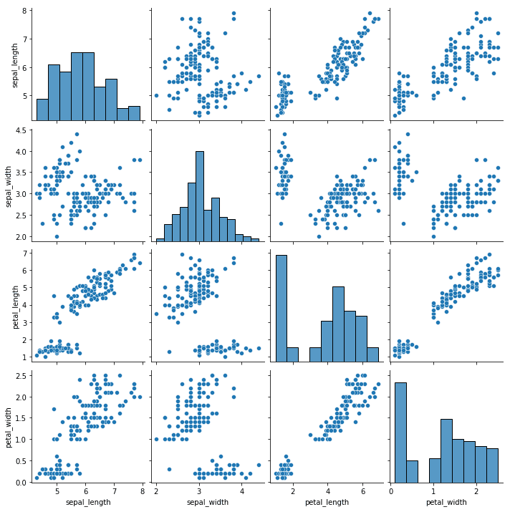
Figure 3.11. Pair Plot

CHAPTER 4:
TOOLS/ HARDWARE & SOFTWARE REQUIREMENTS
HTML and JavaScript: The HTML structure defines the login page content, layout, and interactive elements. JavaScript provides dynamic functionality, including interactions and input validation reCAPTCHA:
This page references Google reCAPTCHA (https://www.gstatic.com/recaptcha) to prevent automated bots from accessing the login system, providing an added layer of security. Wordtune: A script for Wordtune is installed on the page, which might assist in text-related enhancements. Tailwind CSS: Tailwind CSS framework is applied for utility-based styling, allowing modular design and rapid customization.
Font Awesome Icons: Several icon classes (svg-inline--fa) suggest the use of Font Awesome for icons, aiding in visual cues for users on the login page.

HARDWARE-REQUIRMENTS:
- System : i3 or above.
- Ram : 4 GB.
- Hard Disk : 40 GB
SOFTWARE REQUIRMENTS :
- Operating system : Windows8 or Above.
- Coding Language : python

CHAPTER-5
IMPLEMENTATION
ARCHITECTURE
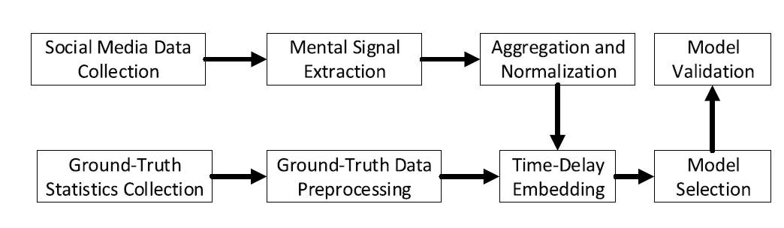
UML DIAGRAMS
UML stands for Unified Modeling Language. UML is a standardized general-purpose modeling language in the field of object-oriented software engineering. The standard is managed, and was created by, the Object Management Group.
The goal is for UML to become a common language for creating models of object oriented computer software. In its current form UML is comprised of two major components: a Meta-model and a notation. In the future, some form of method or process may also be added to; or associated with, UML.
The Unified Modeling Language is a standard language for specifying, Visualization, Constructing and documenting the artifacts of software system, as well as for business modeling and other non-software systems.
The UML represents a collection of best engineering practices that have proven successful in the modeling of large and complex systems.
The UML is a very important part of developing objects oriented software and the software development process. The UML uses mostly graphical notations to express the design of software projects.

GOALS:
The Primary goals in the design of the UML are as follows:
- Provide users a ready-to-use, expressive visual modeling Language so that they can develop and exchange meaningful models.
- Provide extendibility and specialization mechanisms to extend the core concepts.
- Be independent of particular programming languages and development process.
- Provide a formal basis for understanding the modeling language.
- Encourage the growth of OO tools market.
- Support higher level development concepts such as collaborations, frameworks, patterns and components.
- Integrate best practices.
USE CASE DIAGRAM:
A use case diagram in the Unified Modeling Language (UML) is a type of behavioral diagram defined by and created from a Use-case analysis. Its purpose is to present a graphical overview of the functionality provided by a system in terms of actors, their goals (represented as use cases), and any dependencies between those use cases. The main purpose of a use case diagram is to show what system functions are performed for which actor. Roles of the actors in the system can be depicted.
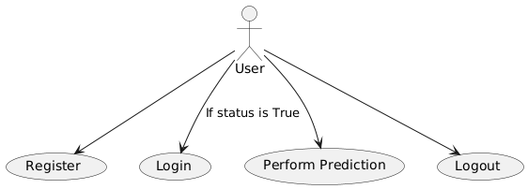
CLASS DIAGRAM:
In software engineering, a class diagram in the Unified Modeling Language (UML) is a type of static structure diagram that describes the structure of a system by showing the system's classes, their attributes, operations (or methods), and the relationships among the classes. It explains which class contains information
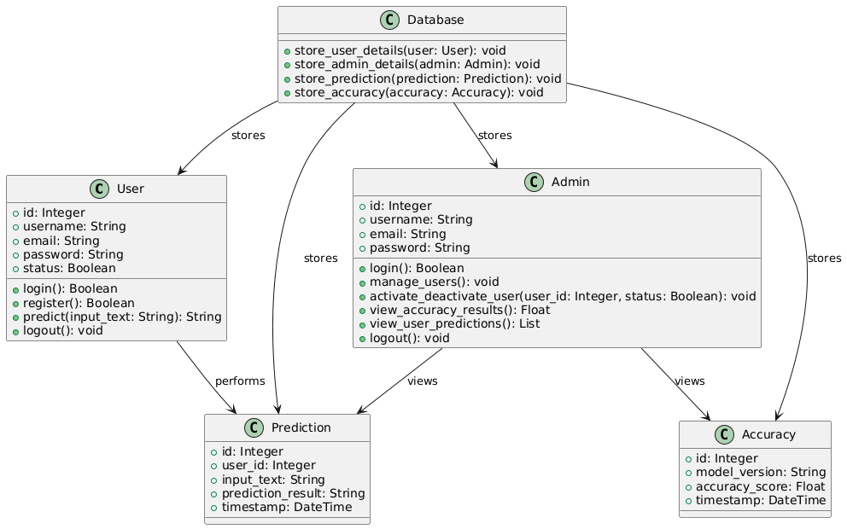
ACTIVITY DIAGRAM:
Activity diagrams are graphical representations of workflows of stepwise activities and actions with support for choice, iteration and concurrency. In the Unified Modeling Language, activity diagrams can be used to describe the business and operational step-by-step workflows of components in a system. An activity diagram shows the overall flow of control.
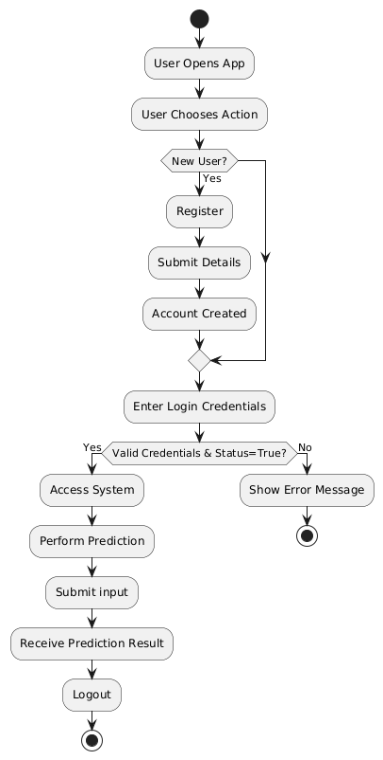
Fig: Activity Diagram for User Workflow
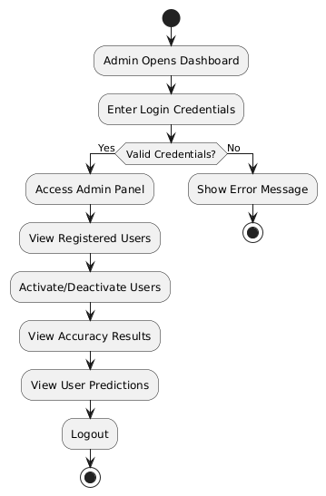
Fig: Activity Diagram for Admin Workflow
SEQUENCE DIAGRAM:
A sequence diagram in Unified Modeling Language (UML) is a kind of interaction diagram that shows how processes operate with one another and in what order. It is a construct of a Message Sequence Chart. Sequence diagrams are sometimes called event diagrams, event scenarios, and timing diagrams
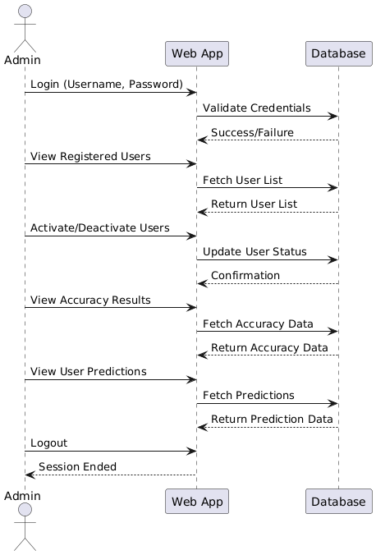
COLLABORATION DIAGRAM FOR USER WORKFLOW

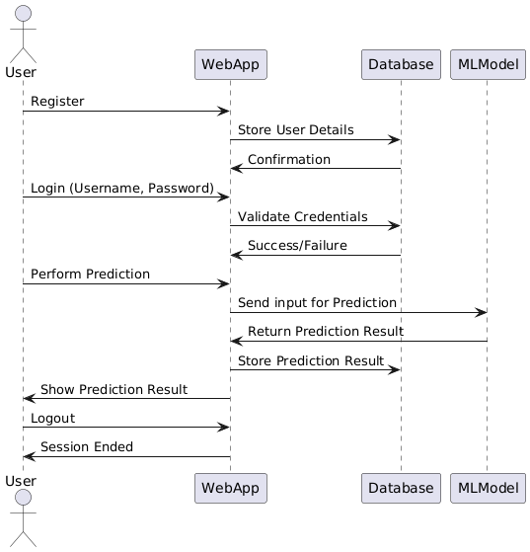

COLLABORATION DIAGRAM FOR ADMIN WORKFLOW
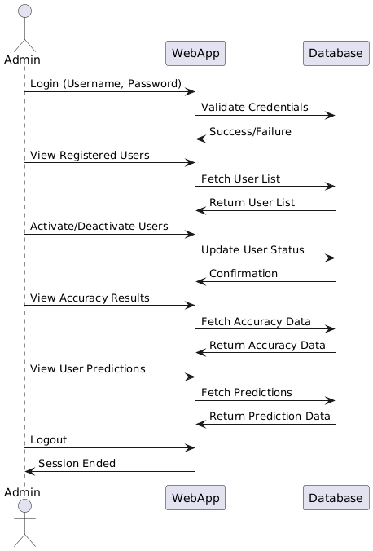

COMPONENT DIAGRAM
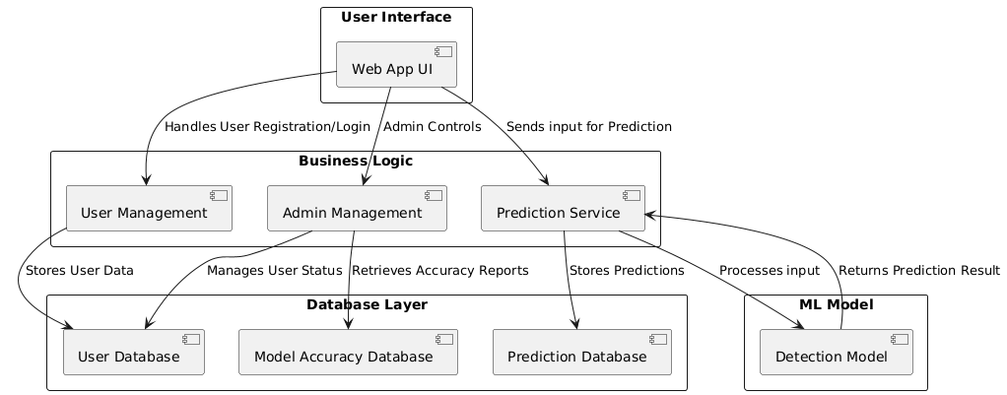

DEPLOYMENT DIAGRAM
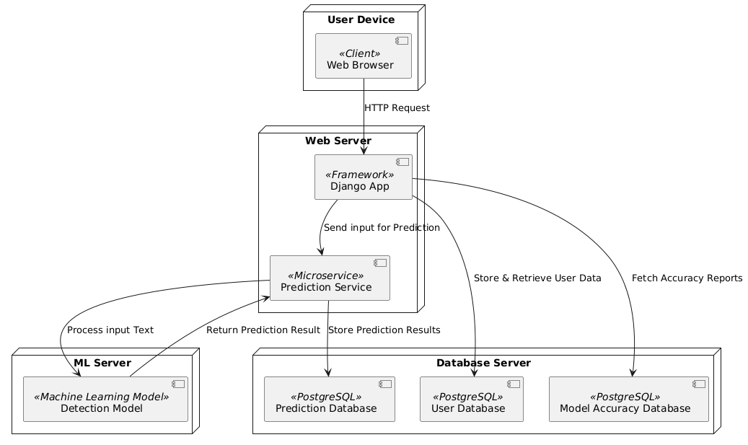
DATA FLOW DIAGRAM:

- The DFD is also called as bubble chart. It is a simple graphical formalism that can be used to represent a system in terms of input data to the system, various processing carried out on this data, and the output data is generated by this system.
- The data flow diagram (DFD) is one of the most important modeling tools. It is used to model the system components. These components are the system process, the data used by the process, an external entity that interacts with the system and the information flows in the system.
- DFD shows how the information moves through the system and how it is modified by a series of transformations. It is a graphical technique that depicts information flow and the transformations that are applied as data moves from input to output.
- DFD is also known as bubble chart. A DFD may be used to represent a system at any level of abstraction. DFD may be partitioned into levels that represent increasing information flow and functional detail.

DFD-0
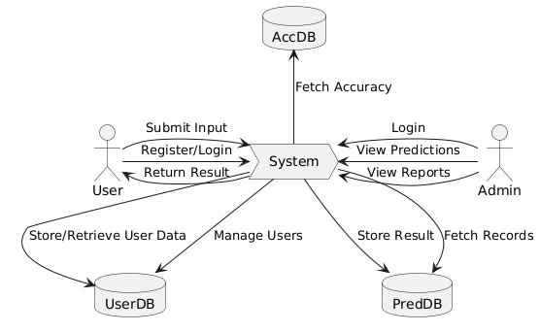

DFD-1
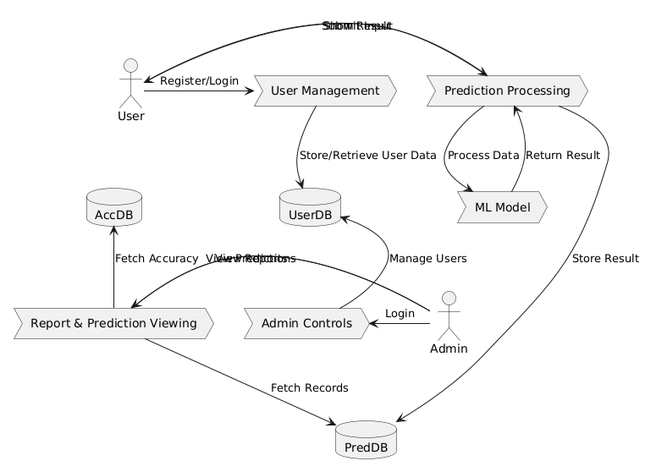

CHAPTER-6
SOURCE CODE
ADMIN
from django.shortcuts import render, redirect
from django.contrib.auth.models import User
from django.contrib import messages
from User.models import PredictionResult
from django.core.paginator import Paginator

from django.http import HttpResponse
from django.core.files.storage import FileSystemStorage
import os
from xgboost import XGBRegressor
from sklearn.feature_extraction.text import TfidfVectorizer
from sklearn.model_selection import train_test_split
from sklearn.metrics import mean_squared_error, r2_score
import pandas as pd

def adminhome(request):
users = User.objects.filter(is_staff=False, is_superuser=False)
return render(request, "Admin/adminhome.html", {"users": users})

def admin_update_userstatus(request, user_id):
try:
user = User.objects.get(id=user_id)

# Toggle the is_active status
user.is_active = not user.is_active
user.save()

# Display message based on the action
if user.is_active:
messages.success(request, f"User {user.username} has been activated.")
else:
messages.success(request, f"User {user.username} has been deactivated.")

return redirect('adminhome') # Redirect back to the admin home page
except User.DoesNotExist:
messages.error(request, "User not found.")
return redirect('adminhome')

def adminuserpredictions(request):
predictions = PredictionResult.objects.all().order_by('-created_at')

paginator = Paginator(predictions, 7)
page_number = request.GET.get('page')
page_obj = paginator.get_page(page_number)

return render(request, 'Admin/adminuserpredictions.html', {'page_obj': page_obj})

from collections import Counter
import json

def adminresultratio(request):
# Fetch all PredictionResult objects
predictions = PredictionResult.objects.all()

# Calculate ratios for sentiment, emotion, and suicidal results
sentiment_counts = Counter(pred.sentiment_result for pred in predictions)
emotion_counts = Counter(pred.emotion_result for pred in predictions)
suicidal_counts = Counter(pred.suicidal_result for pred in predictions)

# Convert counts to JSON format for use in templates
sentiment_data = {
"labels": list(sentiment_counts.keys()),
"data": list(sentiment_counts.values())
}
emotion_data = {
"labels": list(emotion_counts.keys()),
"data": list(emotion_counts.values())
}
suicidal_data = {
"labels": list(suicidal_counts.keys()),
"data": list(suicidal_counts.values())
}

context = {
"sentiment_data": json.dumps(sentiment_data),
"emotion_data": json.dumps(emotion_data),
"suicidal_data": json.dumps(suicidal_data),
}

return render(request, 'Admin/adminresultratio.html', context)

def adminaccuracy(request):
metrics = {}
if request.method == 'POST' and request.FILES['uploaded_file']:
# Save the uploaded file
uploaded_file = request.FILES['uploaded_file']
fs = FileSystemStorage()
file_path = fs.save(uploaded_file.name, uploaded_file)
file_full_path = fs.path(file_path)

try:
# Load uploaded CSV file
combined_data = pd.read_csv(file_full_path)

# TF-IDF Vectorization
tfidf_vectorizer = TfidfVectorizer(max_features=5000)
X = tfidf_vectorizer.fit_transform(combined_data['Text'].fillna(""))

y_sentiment = combined_data['sentiment']
y_emotion = combined_data['emotion']
y_suicidal = combined_data['suicidal_label']

# Split data
X_train_sentiment, X_test_sentiment, y_train_sentiment, y_test_sentiment = train_test_split(
X, y_sentiment, test_size=0.3, random_state=42
)
X_train_emotion, X_test_emotion, y_train_emotion, y_test_emotion = train_test_split(
X, y_emotion, test_size=0.3, random_state=42
)
X_train_suicidal, X_test_suicidal, y_train_suicidal, y_test_suicidal = train_test_split(
X, y_suicidal, test_size=0.3, random_state=42
)

# Train XGBoost for Sentiment
xgb_model_sentiment = XGBRegressor(random_state=42, verbosity=1)
xgb_model_sentiment.fit(X_train_sentiment, y_train_sentiment)
sentiment_predictions = xgb_model_sentiment.predict(X_test_sentiment)
sentiment_mse = mean_squared_error(y_test_sentiment, sentiment_predictions)
sentiment_r2 = r2_score(y_test_sentiment, sentiment_predictions)

# Train XGBoost for Emotion
xgb_model_emotion = XGBRegressor(random_state=42, verbosity=1)
xgb_model_emotion.fit(X_train_emotion, y_train_emotion)
emotion_predictions = xgb_model_emotion.predict(X_test_emotion)
emotion_mse = mean_squared_error(y_test_emotion, emotion_predictions)
emotion_r2 = r2_score(y_test_emotion, emotion_predictions)

# Train XGBoost for Suicidal
xgb_model_suicidal = XGBRegressor(random_state=42, verbosity=1)
xgb_model_suicidal.fit(X_train_suicidal, y_train_suicidal)
suicidal_predictions = xgb_model_suicidal.predict(X_test_suicidal)
suicidal_mse = mean_squared_error(y_test_suicidal, suicidal_predictions)
suicidal_r2 = r2_score(y_test_suicidal, suicidal_predictions)

# Store metrics
metrics = {
"Sentiment MSE": sentiment_mse,
"Sentiment R2": sentiment_r2,
"Emotion MSE": emotion_mse,
"Emotion R2": emotion_r2,
"Suicidal MSE": suicidal_mse,
"Suicidal R2": suicidal_r2,
}

except Exception as e:
metrics['error'] = str(e)
finally:
# Clean up uploaded file
os.remove(file_full_path)

return render(request, "Admin/adminaccuracy.html", {"metrics": metrics})
USER
from django.shortcuts import render
from .models import PredictionResult
import pickle

# Create your views here.
def userhome(request):
user = request.user
return render(request, 'User/userhome.html', {'user':user})

def userpredict(request):
result = None
if request.method == 'POST':
input_text = request.POST.get('input_text')
if input_text:
result = predict_sentiment_emotion_suicidal(input_text)
PredictionResult.objects.create(
input_text=input_text,
sentiment_result=result['sentiment'],
emotion_result=result['emotion'],
suicidal_result=result['suicidal']
)

return render(request, 'User/userpredict.html', {'result': result})

# Prediction script
def predict_sentiment_emotion_suicidal(input_text):
# Load the models and vectorizer
with open('model/xgb_model_sentiment.pkl', 'rb') as f:
model_sentiment = pickle.load(f)

with open('model/xgb_model_emotion.pkl', 'rb') as f:
model_emotion = pickle.load(f)

with open('model/xgb_model_suicidal.pkl', 'rb') as f:
model_suicidal = pickle.load(f)

with open('model/tfidf_vectorizer.pkl', 'rb') as f:
vectorizer = pickle.load(f)

# Preprocess input text
input_vector = vectorizer.transform([input_text])

# Predict
sentiment_score = model_sentiment.predict(input_vector)[0]
emotion_score = model_emotion.predict(input_vector)[0]
suicidal_score = model_suicidal.predict(input_vector)[0]

# Map scores to labels
sentiment_label = (
"negative" if sentiment_score < -0.5 else
"neutral" if -0.5 <= sentiment_score <= 0.5 else
"positive"
)

emotions = [
"anger", "anticipation", "disgust", "fear",
"joy", "sadness", "surprise", "optimism"
]
emotion_label = emotions[int(round(emotion_score)) % len(emotions)]

suicidal_label = "suicidal" if suicidal_score > 0.3 else "non-suicidal"

return {
"sentiment": sentiment_label,
"emotion": emotion_label,
"suicidal": suicidal_label
}

SCREEN SHOTS

Fig: Anaconda navigator

Fig: Creating an Environment
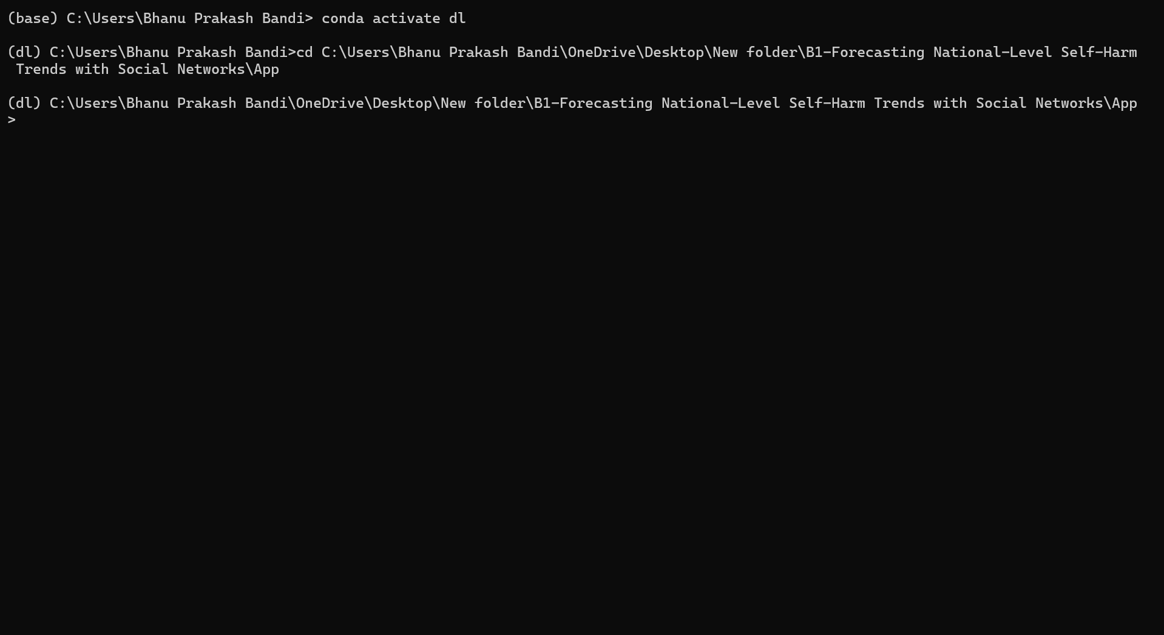
Fig: Entering In to Project Environment
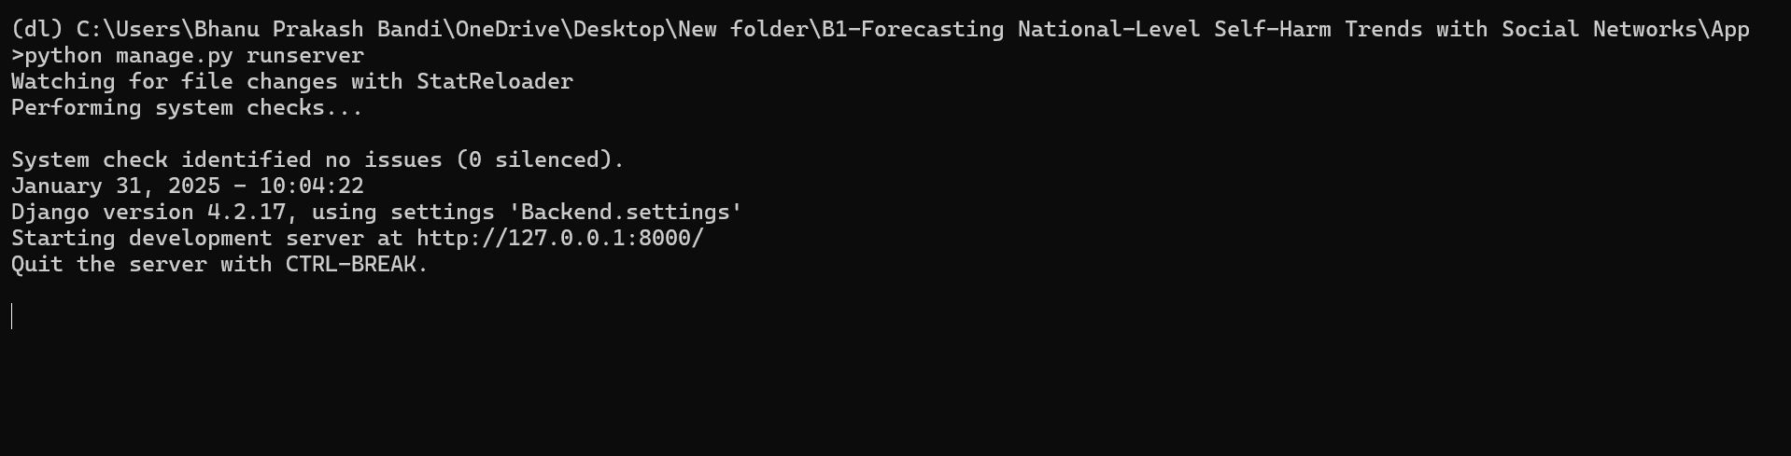
Fig: Running Your Project
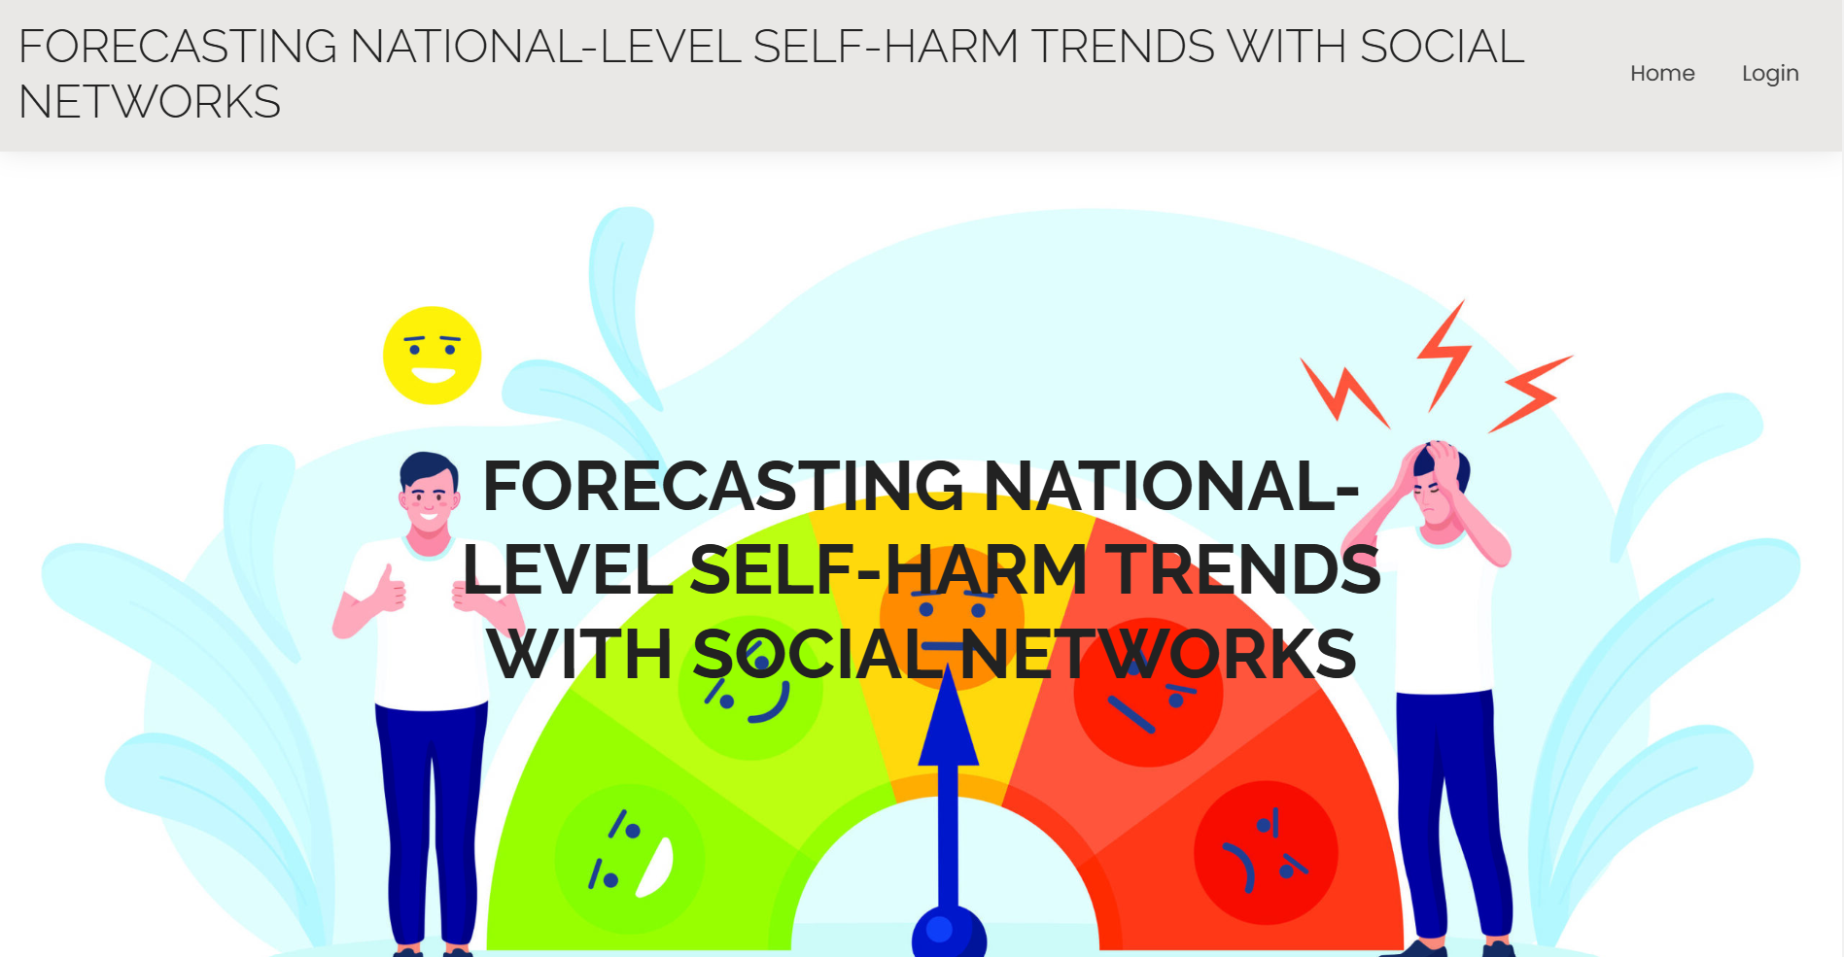
Fig: Index Page
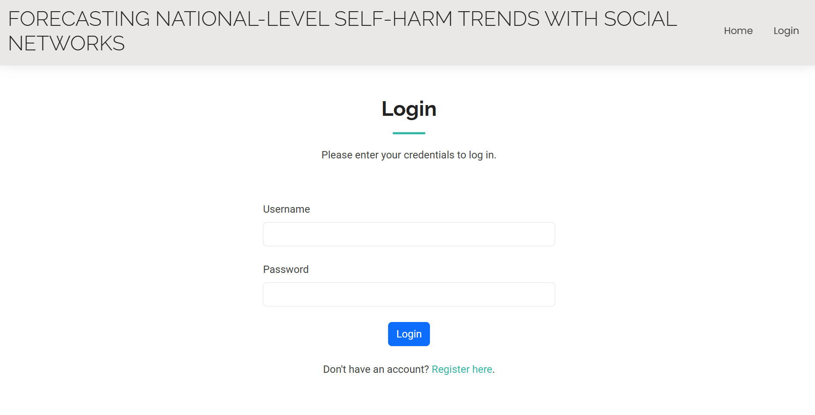
Fig: Login Page Which is used For Both Users and Admin
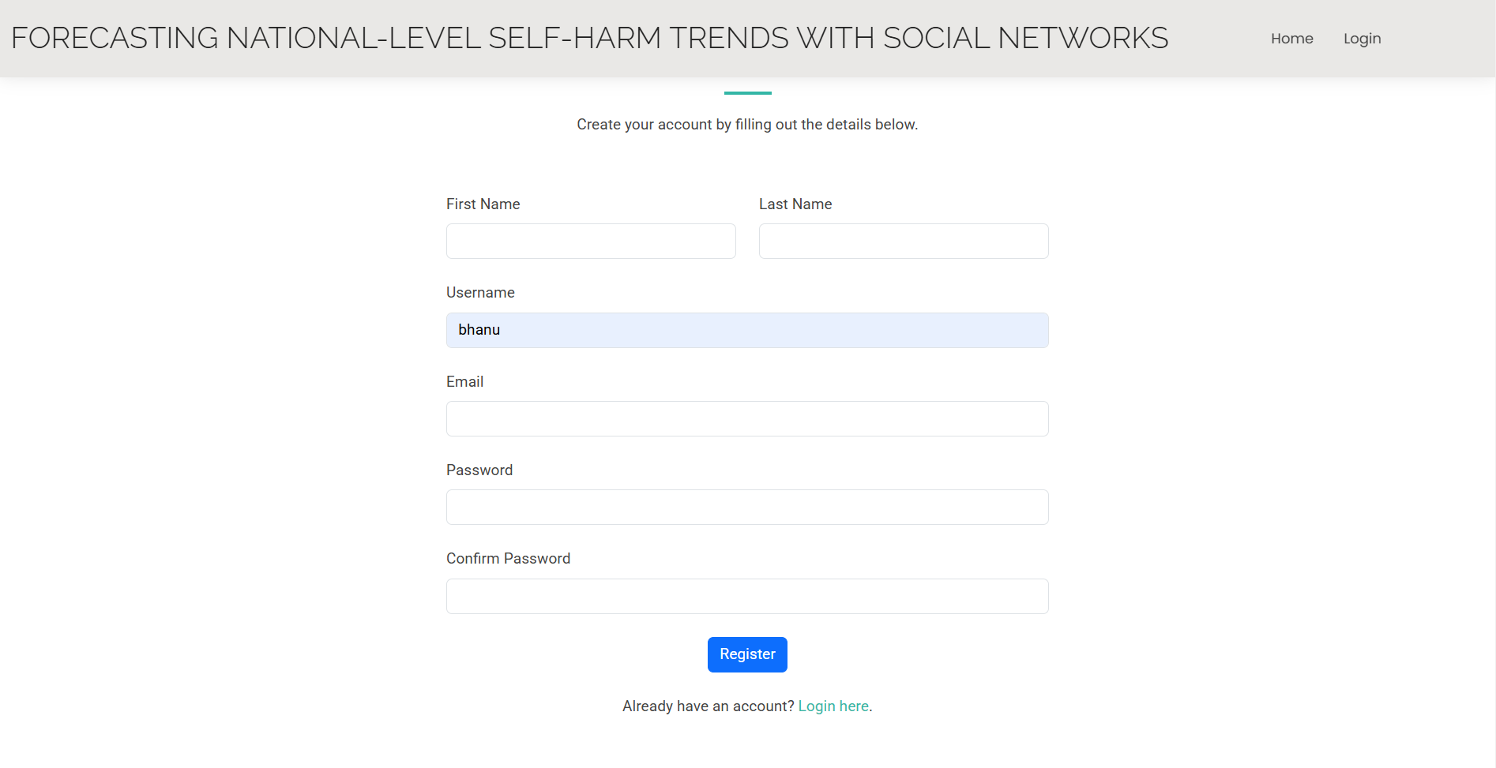
Fig: User Registration Page
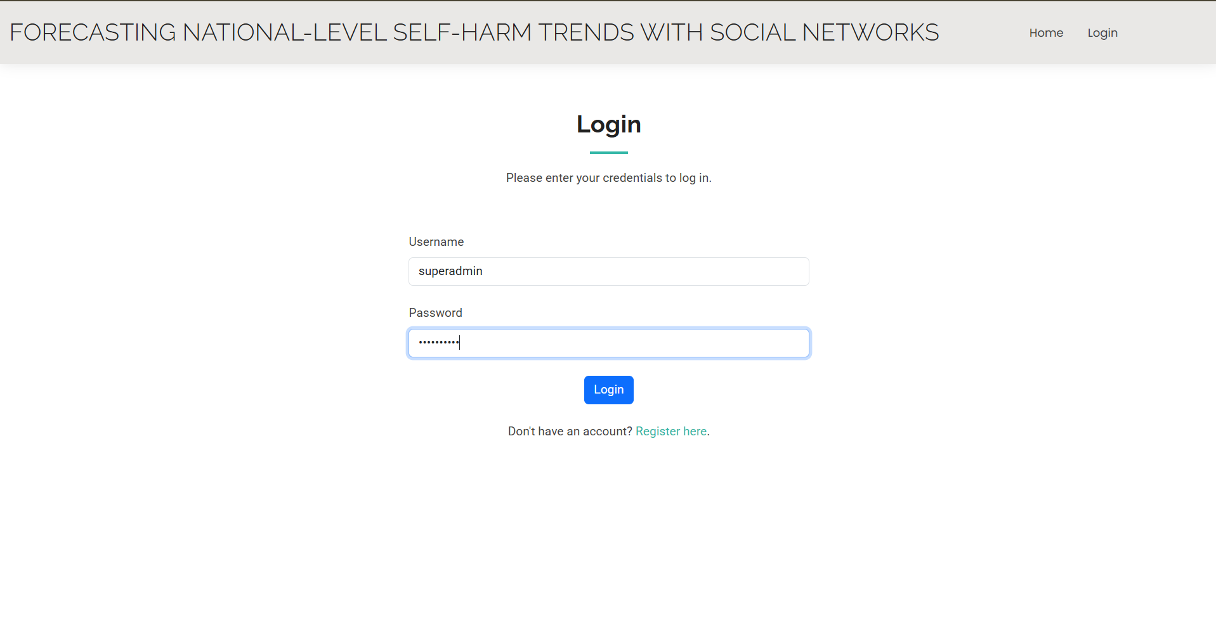
Login Admin Page
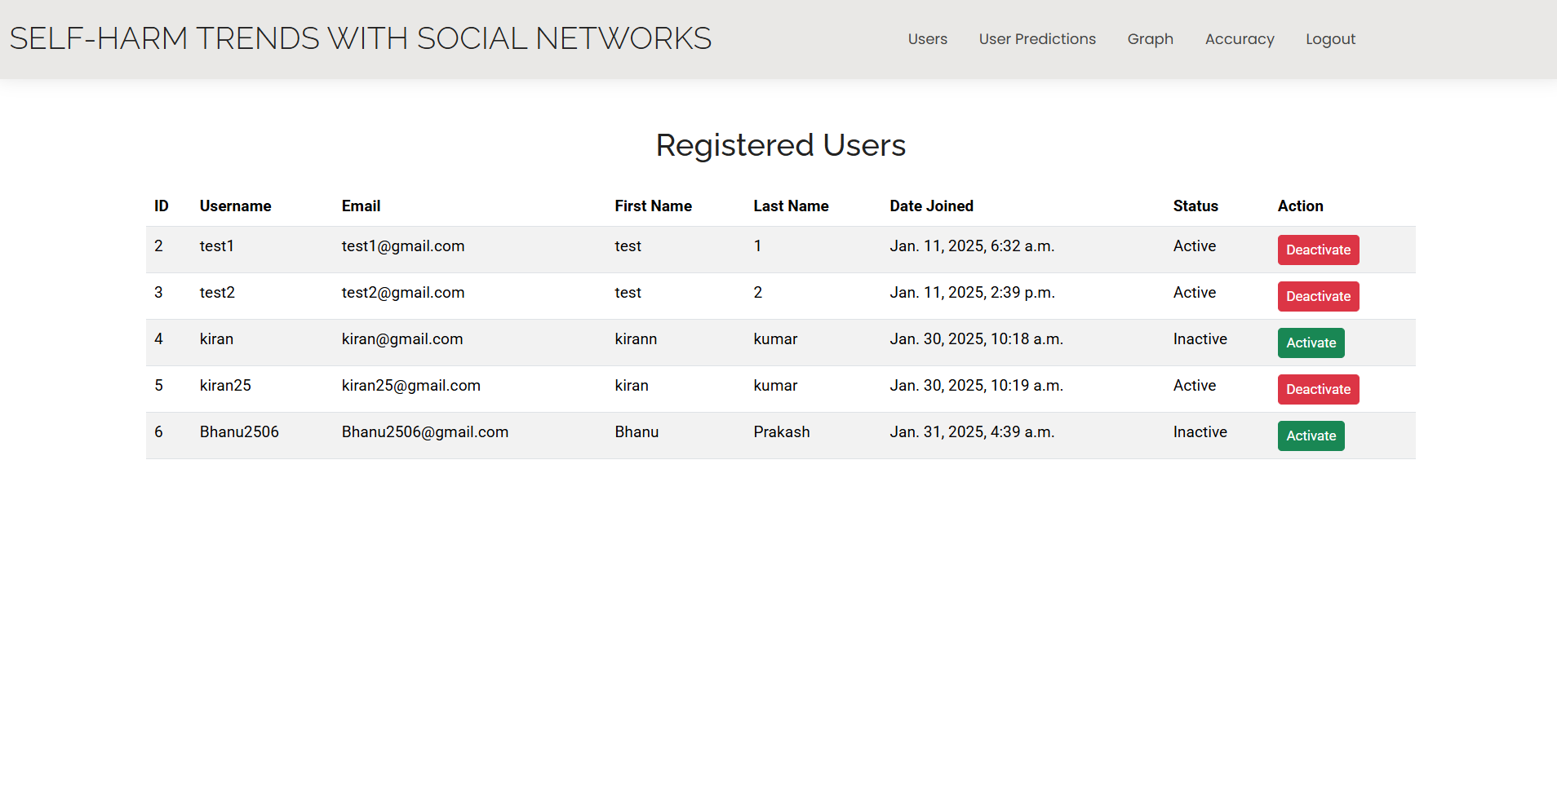
Fig: List Of Users In Admin Page
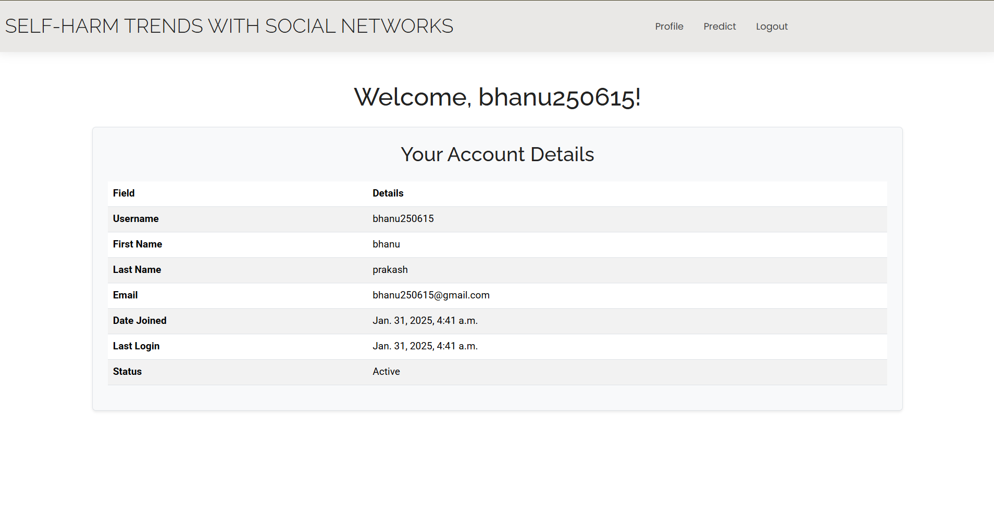
Fig: User Login Page Displaying User Detials
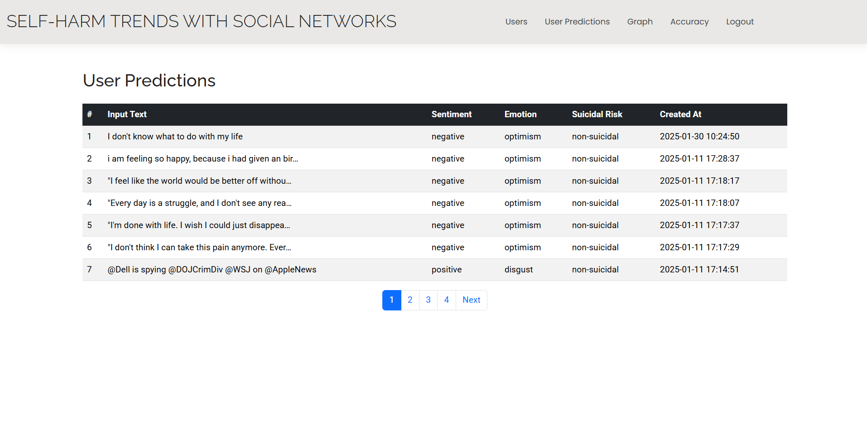
Fig: User Predictions In admin Page
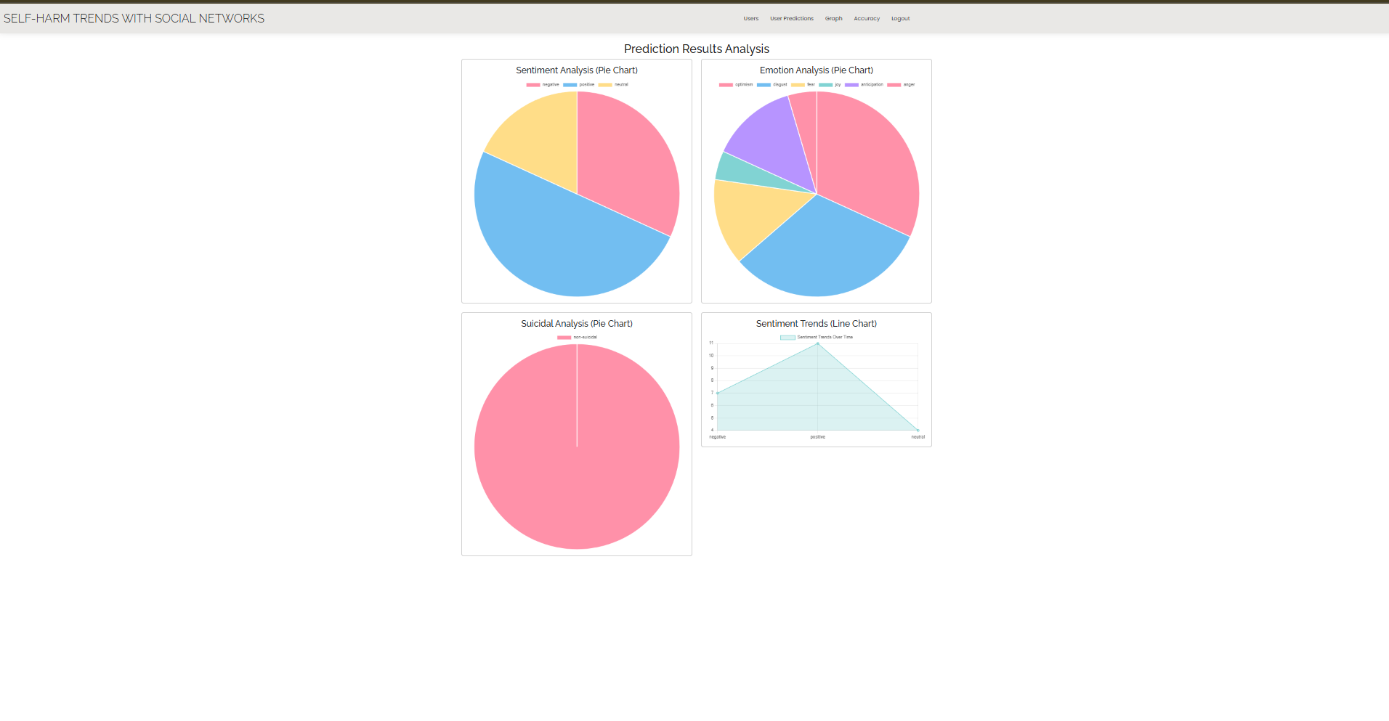
Fig: Prediction Analysis
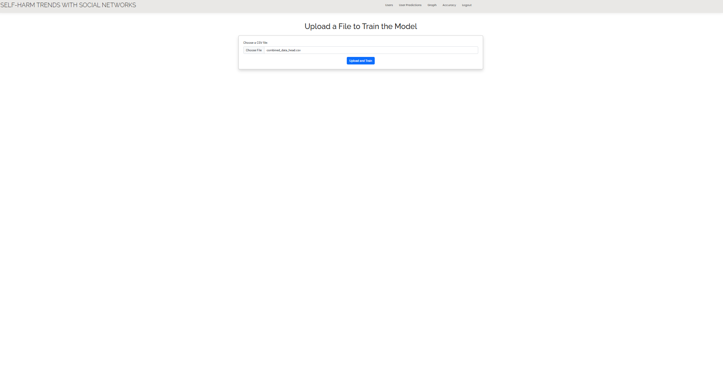
Fig: Uploading Data Set To Train and get accuracy
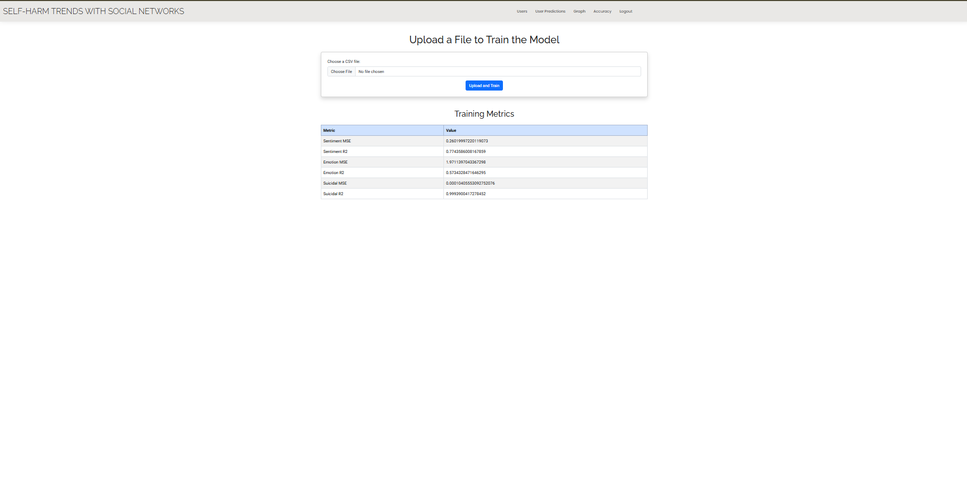
Fig: After training You are getting accuracy values
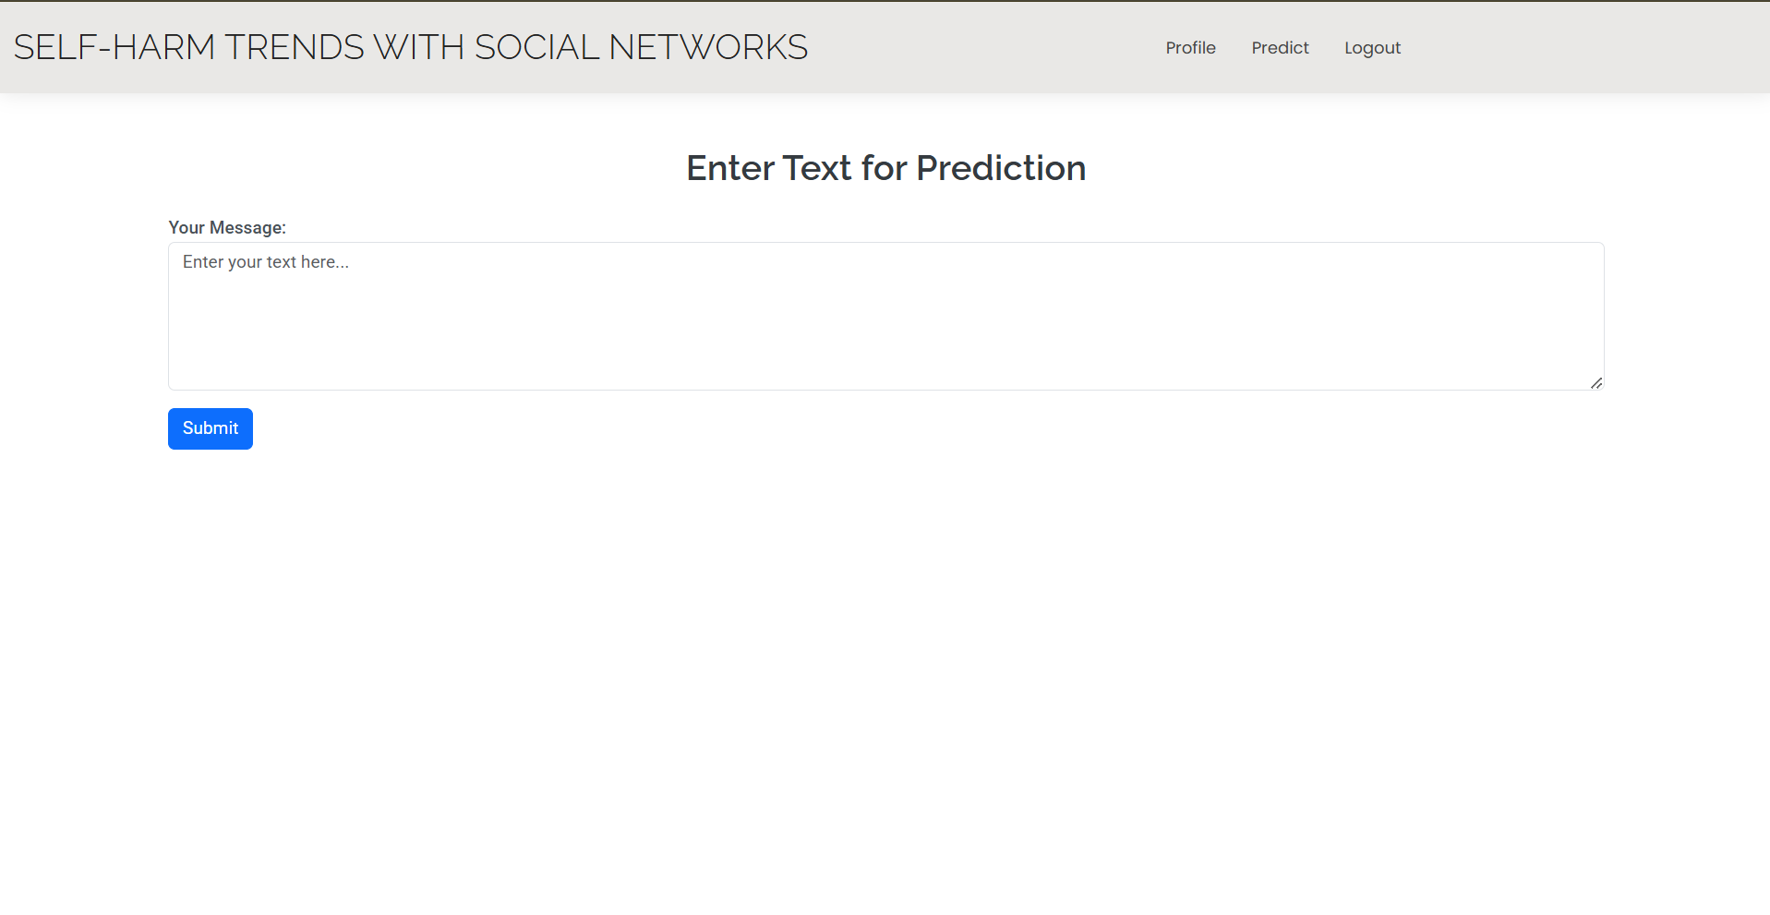
Fig: Displaying User to predict the data
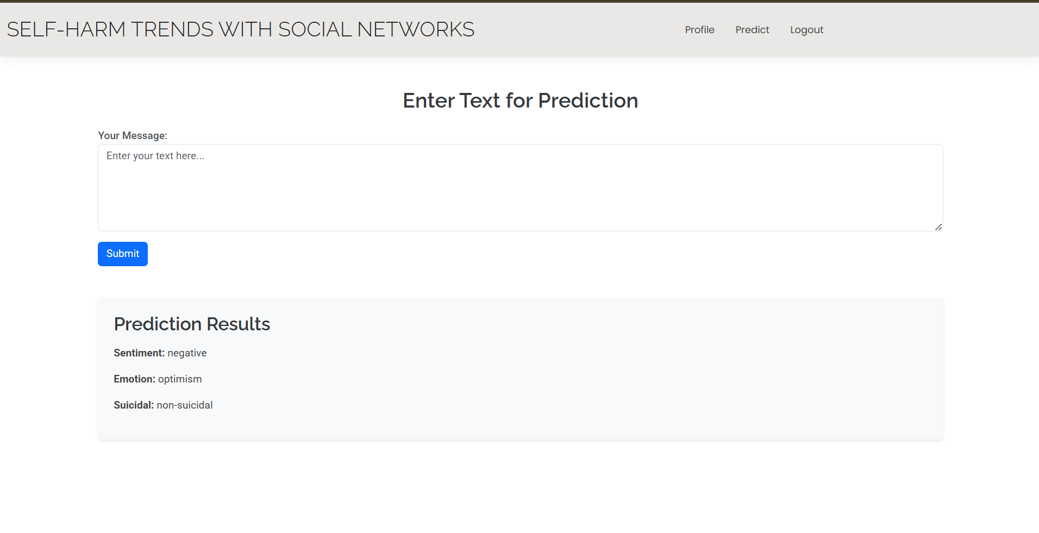
Fig: After Passing Values The Predicted Result we are getting

CONCLUSION
Self-harm refers to acts of self-poisoning or self-injury that, regardless of intention, result in death or non-fatal injuries. Research has shown the rising trends of self-harm associated with the advent of technologies and rapid urbanization in developing countries. The ability to forecast or even nowcast national-level self-harm trends could prove crucial for policymakers and public health stakeholders in implementing timely procedures to neutralize the root causes or prevent these anticipated tragedies. While previous work has used historical statistics to forecast population-level self-harm, in certain countries, such ground-truth previous statistics may be unavailable, insufficient, and delayed, hindering the timely monitoring of the self-harm landscape for proactive policymaking purposes. This paper proposed FAST, a framework for forecasting population-level self-harm trends using mental signals extracted from large-scale social media data. A case study using a set of 12 mental signals extracted from tweets to improve the forecastability of the death and injury cases from self-harm in Thailand illustrated the applicability of the proposed method that outperforms the traditional ARIMA baseline by 43.56% and 36.48% on average in terms of MAPE, respectively. To the best of our knowledge, we are the first to investigate using aggregate social media data to improve nowcasting and forecasting self-harm cases at the national level. While the experimental results are promising,there is still room for improvement. Future research could investigate the use of other online media, such as news articles, other social media platforms, or types of media, such as videos or photos in addition to texts, as well as deep learning forecasting techniques. Moreover, it would be worthwhile to investigate the potential for predicting incidents of self-harm on a more granular, such as regional or demographic-specific, scale. This could facilitate the development of tailored self-harm management approaches that are appropriate for specific localities and demography.
REFERENCES
[1] (May 2023). Suicide Rates for Girls Are Rising. Are Smartphones to Blame? [Online]. Available: https://www.economist.com/graphic-detail/ 2023/05/03/suicide-rates-for-girls-are-rising-are-smartphones-to-blame
[2] J. Adam-Troian and T. Arciszewski, ‘‘Absolutistwords from search volume data predict state-level suicide rates in the United States,’’ Clin. Psychol. Sci., vol. 8, no. 4, pp. 788–793, Jul. 2020.
[3] A. E. Aiello, A. Renson, and P. Zivich, ‘‘Social media-and Internet-based disease surveillance for public health,’’ Annu. Rev. Public Health, vol. 41, p. 101, Apr. 2020.
[4] M. Akyuz and C. Karul, ‘‘The effect of economic factors on suicide: An analysis of a developing country,’’ Int. J. Hum. Rights Healthcare, Jul. 2022.
[5] S. Z. Alavijeh, F. Zarrinkalam, Z. Noorian, A. Mehrpour, and K. Etminani, ‘‘What users’ musical preference on Twitter reveals about psychological disorders,’’ Inf. Process. Manage., vol. 60, no. 3, May 2023, Art. no. 103269.
[6] A. Aldayel and W. Magdy, ‘‘Stance detection on social media: State of the art and trends,’’ Inf. Process. Manage., vol. 58, no. 4, Jul. 2021, Art. no. 102597.
[7] P. Angelov and A. Sperduti, ‘‘Challenges in deep learning,’’ in Proc. 24th Eur. Symp. Artif. Neural Netw. (ESANN), 2016, pp. 489–496.
[8] A. Apisarnthanarak, P. Apisarnthanarak, C. Siripraparat, P. Saengaram, N. Leeprechanon, and D. J. Weber, ‘‘Impact of anxiety and fear for COVID-19 toward infection control practices among Thai healthcare workers,’’ Infection Control Hospital Epidemiol., vol. 41, no. 9, pp. 1093–1094, Sep. 2020.
[9] S. Arunpongpaisal, S. Assanagkornchai, V. Chongsuvivatwong, and N. Jampathong, ‘‘Time-series analysis of trends in the incidence rates of successful and attempted suicides in Thailand in 2013–2019 and their predictors,’’ BMC Psychiatry, vol. 22, no. 1, pp. 1–11, Aug. 2022.
[10] J. M. Barros, R. Melia, K. Francis, J. Bogue, M. O’Sullivan, K. Young, R. A. Bernert, D. Rebholz-Schuhmann, and J. Duggan, ‘‘The validity of Google trends search volumes for behavioral forecasting of national suicide rates in Ireland,’’ Int. J. Environ. Res. Public Health, vol. 16, no. 17, p. 3201, Sep. 2019.

